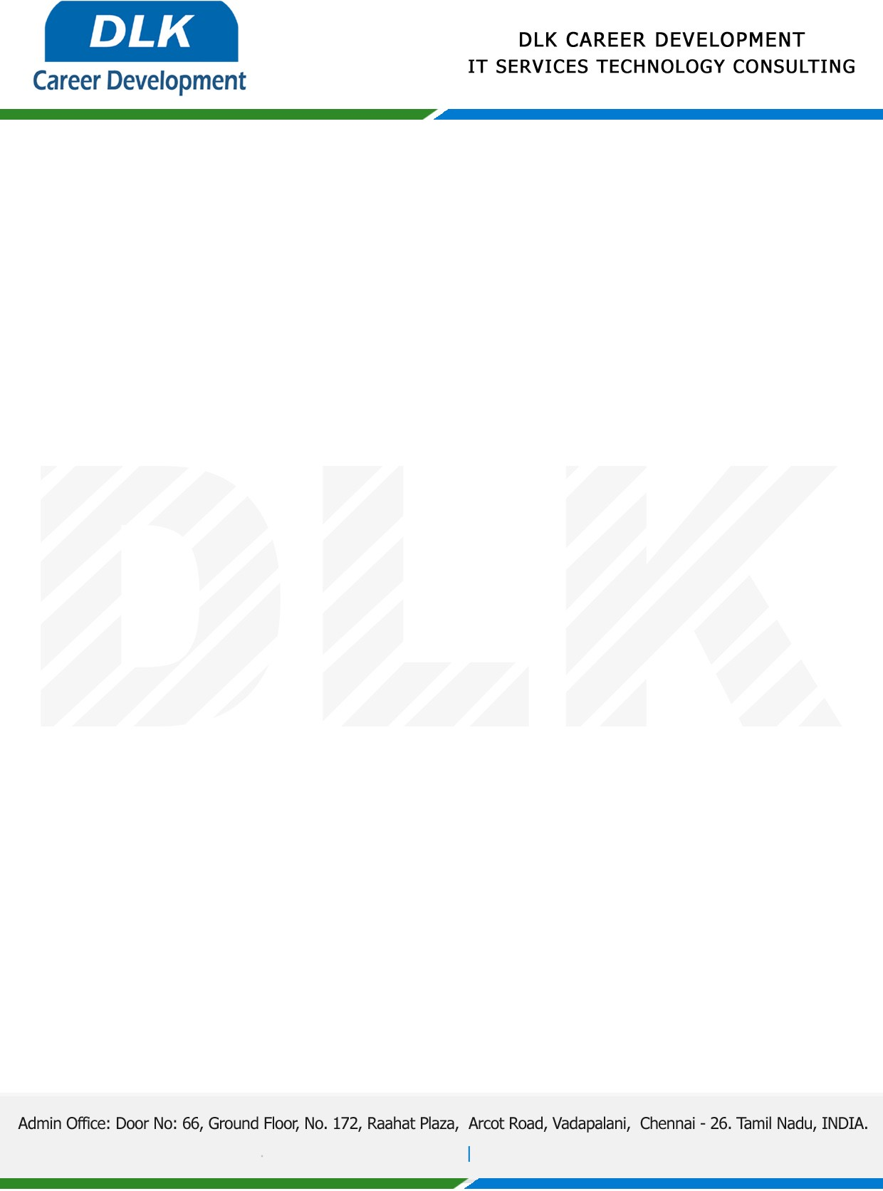

Date: 21/February / 2023

**To**

Department of BCA ( [Computer Application),](https://www.cseindia.org/)

Head of Department,

Alpha arts and science college, Chennai - 600116.

**Sub: Letter of Project Acceptance**

This is to certify that final year students of has accepted the Project Work duration from **23rd February 2023** to **15th April 2023** under the domain **“Java”.** During the Project, all information and data collected from you should be kept confidential.

**Team Members:**

1. MR VIJAY K (REG NO 212002793)
2. MR LAXMAN A (REG NO: 212002756)
3. MR MOHAMMED ASIF J (REG NO: 212002760)

**Topic:** Students Results Management System.

We appreciate your interest in **DLK CAREER DEVELOPMENT**

